Practical no. 01

Implement depth first search algorithm and Breadth First Search algorithm. Use an undirected graph and develop a recursive algorithm for searching all the vertices of a graph or tree data structure.

**Code:**

from collections import defaultdict, deque

class Graph:

def __init__(self):

# Default dictionary to store graph

self.graph = defaultdict(list)

def add_edge(self, u, v):

self.graph[u].append(v)

self.graph[v].append(u) # Since it's undirected, add the reverse edge as well.

def dfs_recursive(self, vertex, visited=None):

if visited is None:

visited = set()

visited.add(vertex)

print(vertex, end=' ')

for neighbor in self.graph[vertex]:

if neighbor not in visited:

self.dfs_recursive(neighbor, visited)

def bfs(self, start):

visited = set() # To keep track of visited nodes

queue = deque([start]) # Use deque for an efficient queue implementation

visited.add(start)

while queue:

vertex = queue.popleft() # Pop the front of the queue

print(vertex, end=' ')

# Add all unvisited neighbors to the queue

for neighbor in self.graph[vertex]:

if neighbor not in visited:

queue.append(neighbor)

visited.add(neighbor)

# Example usage:

g = Graph()

g.add_edge(0, 1)

g.add_edge(0, 2)

g.add_edge(1, 2)

g.add_edge(2, 3)

g.add_edge(3, 4)

print("Depth First Search (starting from vertex 0):")

g.dfs_recursive(0)

print("\nBreadth First Search (starting from vertex 0):")

g.bfs(0)

**Output:**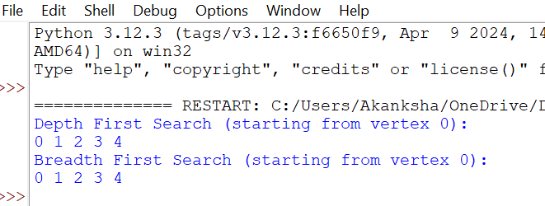

Practical no. 02

Implement A star (A*) Algorithm for any game search problem

**Code:**

import heapq

class AStar:

def __init__(self, grid, start, goal):

self.grid = grid # 2D grid where 0 = walkable, 1 = blocked

self.start = start # Start position (x, y)

self.goal = goal # Goal position (x, y)

self.rows = len(grid)

self.cols = len(grid[0])

def heuristic(self, node):

# Manhattan distance heuristic

return abs(node[0] - self.goal[0]) + abs(node[1] - self.goal[1])

def neighbors(self, node):

# Return valid neighbors (up, down, left, right)

dirs = [(0, 1), (1, 0), (0, -1), (-1, 0)] # Directions: right, down, left, up

result = []

for d in dirs:

neighbor = (node[0] + d[0], node[1] + d[1])

if 0 <= neighbor[0] < self.rows and 0 <= neighbor[1] < self.cols and self.grid[neighbor[0]][neighbor[1]] == 0:

result.append(neighbor)

return result

def a_star_search(self):

# Priority queue to store (f_score, node)

open_list = []

heapq.heappush(open_list, (0, self.start))

came_from = {} # For reconstructing path

g_score = {self.start: 0} # Cost from start to each node

f_score = {self.start: self.heuristic(self.start)} # Estimated cost from start to goal

while open_list:

current = heapq.heappop(open_list)[1]

# If we reached the goal, reconstruct the path

if current == self.goal:

return self.reconstruct_path(came_from, current)

for neighbor in self.neighbors(current):

tentative_g_score = g_score[current] + 1 # Distance from current to neighbor is 1

if neighbor not in g_score or tentative_g_score < g_score[neighbor]:

# Update the best path to the neighbor

came_from[neighbor] = current

g_score[neighbor] = tentative_g_score

f_score[neighbor] = tentative_g_score + self.heuristic(neighbor)

heapq.heappush(open_list, (f_score[neighbor], neighbor))

return [] # Return empty path if no solution

def reconstruct_path(self, came_from, current):

# Reconstruct path from came_from dictionary

total_path = [current]

while current in came_from:

current = came_from[current]

total_path.append(current)

return total_path[::-1] # Reverse path to start from the beginning

# 0 = walkable, 1 = blocked

grid = [

[0, 1, 0, 0, 0],

[0, 1, 0, 1, 0],

[0, 0, 0, 1, 0],

[1, 1, 0, 0, 0],

[0, 0, 0, 1, 0]

]

start = (0, 0) # Starting position

goal = (4, 4) # Goal position

a_star = AStar(grid, start, goal)

path = a_star.a_star_search()

print("Path from start to goal:", path)

**Output:**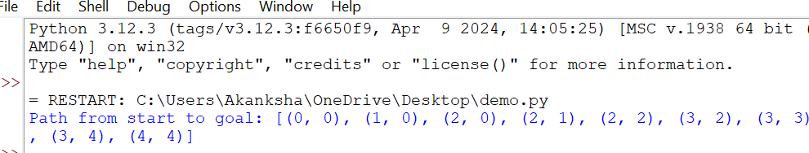

**Practical no. 03**

Implement Greedy search algorithm for any of the following application: • Selection Sort • Minimum Spanning Tree • Single-Source Shortest Path Problem • Job Scheduling Problem • Prim's Minimal Spanning Tree Algorithm • Kruskal's Minimal Spanning Tree Algorithm • Dijkstra's Minimal Spanning Tree Algorithm.

**Code:**

def selection_sort(arr):

n = len(arr)

# Traverse through all array elements

for i in range(n):

# Find the minimum element in the remaining unsorted array

min_index = i

for j in range(i+1, n):

if arr[j] < arr[min_index]:

min_index = j

# Swap the found minimum element with the first element

arr[i], arr[min_index] = arr[min_index], arr[i]

print(f"Step {i+1}: {arr}") # Print the array after each swap

return arr

# Example usage:

arr = [64, 25, 12, 22, 11]

print("Original array:", arr)

sorted_arr = selection_sort(arr)

print("Sorted array:", sorted_arr)

**Output:**

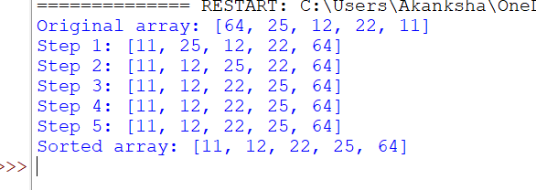

**Practical no.04**

Implement a solution for a Constraint Satisfaction Problem using Branch and Bound and Backtracking for n-queens problem or a graph coloring problem.

**Code:**

def print_board(board):

for row in board:

print(" ".join("Q" if col else "." for col in row))

print("\n")

def is_safe(board, row, col, n):

# Check the current column

for i in range(row):

if board[i][col]:

return False

for i, j in zip(range(row, -1, -1), range(col, -1, -1)):

if board[i][j]:

return False

for i, j in zip(range(row, -1, -1), range(col, n)):

if board[i][j]:

return False

return True

def solve_n_queens_backtracking(board, row, n):

if row == n:

# If all queens are placed, print the solution

print_board(board)

return True

found_solution = False

for col in range(n):

if is_safe(board, row, col, n):

board[row][col] = True # Place the queen

# Recur to place the rest of the queens

found_solution = solve_n_queens_backtracking(board, row + 1, n) or found_solution

# If placing the queen at (row, col) didn't lead to a solution, backtrack

board[row][col] = False

return found_solution

def n_queens_backtracking(n):

board = [[False] * n for _ in range(n)] # Initialize n x n board with False (no queens placed)

if not solve_n_queens_backtracking(board, 0, n):

print("No solution exists.")

def is_safe_branch_and_bound(row, col, cols, diags1, diags2, n):

return not (cols[col] or diags1[row + col] or diags2[row - col + (n - 1)])

def solve_n_queens_branch_and_bound(row, n, cols, diags1, diags2, board):

if row == n:

# If all queens are placed, print the solution

print_board(board)

return True

found_solution = False

for col in range(n):

if is_safe_branch_and_bound(row, col, cols, diags1, diags2, n):

# Place the queen

board[row][col] = True

cols[col] = True

diags1[row + col] = True

diags2[row - col + (n - 1)] = True

# Recur to place the rest of the queens

found_solution = solve_n_queens_branch_and_bound(row + 1, n, cols, diags1, diags2, board) or found_solution

board[row][col] = False

cols[col] = False

diags1[row + col] = False

diags2[row - col + (n - 1)] = False

return found_solution

def n_queens_branch_and_bound(n):

board = [[False] * n for _ in range(n)] # Initialize n x n board with False (no queens placed)

cols = [False] * n

diags1 = [False] * (2 * n - 1) # For "/" diagonals

diags2 = [False] * (2 * n - 1) # For "\" diagonals

if not solve_n_queens_branch_and_bound(0, n, cols, diags1, diags2, board):

print("No solution exists.")

**Output:**

Solving n-Queens using Backtracking:

. Q . .

. . . Q

Q . . .

. . Q .

. . Q .

Q . . .

. . . Q

. Q . .

Pratical no5

Simple Chat Bot

In[5]:

Pip installnltk

.

**import**nltk

**from**nltk.chat.util**import**Chat,reflections

**import**tkinter**as**tk

**from**tkinter**import**scrolledtext

*#Definechatbotresponsesusingpairs*

pairs**=**[

[r"hi|hello|hey",["Hello!HowcanIassistyoutoday?","Hithere!HowcanIh[r"howareyou?",["I'mjustabot,butI'mdoingfine!Howaboutyou?","I'ma[r"(.*)yourname?",["I'machatbot,heretoassistyou."]],

[r"bye|goodbye", ["Goodbye! Have a great day!", "Bye! Take care!"]],[r"(.*)",["I'mnotsurehowtorespondtothat.Couldyourephrase?"]]

]

*#Createchatbot*

chatbot**=**Chat(pairs,reflections)

**def**send_message():

user_input**=**user_entry**.**get()

chat_history**.**insert(tk**.**END,f"You:{user_input}\n")response**=**chatbot**.**respond(user_input)

chat_history**.**insert(tk**.**END,f"Bot:{response}\n\n")user_entry**.**delete(0,tk**.**END)

*#GUIsetup*

root**=**tk**.**Tk()

root**.**title("SimpleChatbot")

chat_history**=**scrolledtext**.**ScrolledText(root,wrap**=**tk**.**WORD,width**=**50,height**=**15)chat_history**.**pack(padx**=**10,pady**=**10)

user_entry**=**tk**.**Entry(root,width**=**40)user_entry**.**pack(padx**=**10,pady**=**5)

send_button**=**tk**.**Button(root,text**=**"Send",command**=**send_message)send_button**.**pack(pady**=**5)

In[2]:

root**.**mainloop()

**Output**

